Best Roomies: Requirements Document (version 1.0)

Project:Best Roomies
Date(s): 1st February,2015
Prepared by:Gautam Koundinya

Document status: Draft : Proposed : Validated : Approved

1. Introduction

It is our inherent nature, that the people we are surrounded with have an effect on our outlook towards life .Our friends affect our personal and professional well being. Roommates are closest friends we have during our single lives having an effect on our day-to-day life.If we live with people matching our personal and professional aspirations , we have a good chance to prosper towards our interests. Best Roomies aims to help the youth find the right people to live with.

Best Roomies helps the youth find shared /paying guest accommodation and provides solutions to make the shared living comfortable. Best Roomies is an easy to use website providing effective localized search to post / lookup various Paying Guest and Shared Accommodation across the city .The user can sort the listings by various parameters to zero in on the accommodation most suitable to her / his requirement.

Best Roomies extends its services post finding accommodation to make shared living more comfortable. We provide online work platform to collaborate and manage roommate tasks viz. split cost monthly expenses, grocery list for shopping, fridge wall for messaging amongst mates, payment of Utility bills and classifieds. Best Roomies intends to generate revenue through Premium Ads, Contextual Advertising and charges for applications offered for roommate management

1.1 Purpose of This Document
This document is intended to guide development of Best Roomies. It will go through several stages during the course of the project:
- Draft: The first version, or draft version, is compiled after requirements have been discovered, recorded, classified, and prioritized.
- Proposed: The draft document is then proposed as a potential requirements specification for the project. The proposed document should be reviewed by several parties, who may comment on any requirements and any priorities, either to agree, to disagree, or to identify missing requirements. Readers include end-users, developers, project managers, and any other stakeholders. The document may be amended and reproposed several times before moving to the next stage.
- Validated: Once the various stakeholders have agreed to the requirements in the document, it is considered validated.
- Approved: The validated document is accepted by representatives of each party of stakeholders as an appropriate statement of requirements for the project. The developers then use the requirements document as a guide to implementation and to check the progress of the project as it develops.

1.2 How to Use This Document
We expect that this document will be used by people with different skill sets. This section explains which parts of this document should be reviewed by various types of readers.

Types of Reader
In this section, list the different types of reader this document is aimed at. For example, Flash programmers, graphic designers, end-users,. For each type of reader, clearly state which sections are most pertinent to them, and which may be safely skipped.

- Web Developers – PHP , HTML , CSS , Zend Framework
- UI professional
- UX Professional – CSS Bootstrap

Technical Background Required
This document is to help the Web developer / UI-UX professional gain grasp of the requirement, and help implement these requirements to website , and communicate clarifications needed on any requirements .

1.4 Business Case for the Product
.

There are currently few websites like roomys.in, sulekha.com , OLX and Facebook groups which help the youth find accommodation. However, Bestroomies intends to go beyond the a plain listing website, it helps the user with simple application which can simplify their lives by matching people and finding best accommodation for our budget

Best Roomies aims to help the landlords find students /working professionals find individuals with good background to benefit their house renting business

1.5 Overview of the Requirements Document
.
Bestroomies.com should serve the following purposes:
- Ability to create accounts
- Ability to Create profile enlisting professional and personal information
- Ability to Contact users using web messaging and getting contact information
- Ability to post an accommodation
- Ability to search for an accommodation using different parameters
- Abilty to choose the duration of stay – long term and Short term.
- Abilty to SMS Users for account verification and providing information
- Abilty to Video Conference to verify / converse among users
- Abilty to create a split cost application (to be added later)
- Abilty to have grocery list application (to be added later)
- Abilty to build apps which could improvise shared living (to be added later)

2. General Description

Best Roomies was conceived to promote Roommate Comraderie! Most of us have the best times of our single lives when we live and share our lives with Roommates who match our personal and professional aspirations. They are our Family away from family. The best advice /best critic would be your roommate!!Best Roomies is an attempt to help find the right roommate who not only shares common interests but also help widen your life experience!Oh! yeah..also help you get the best home for your budget!

Bestroomies.com hopes to be the tool assisting college students / single working professionals find best people to share accommodation.

2.1 Product Perspective

The scope of the project is to help any college student or working professional find accommodation in cities across India. The primary stakeholders are :
- User (Youth between 18-30 years ( Girls and Boys )
- Landlords
- Developers of real estate projects
- Best Roomies Team!

2.2 User Characteristics
- Students aged between 17 to 24 (Boys and Girls )
- Working Professionals aged between 21 to 30 (Boys and Girls)
- Landlords / House owner aged between 20 to 60 (Man and Woman)

User Classes and Characteristics

User Class Name | Critical (Y/N) | Estimated Number of Users in Gurgaon | How They Use the System
Boy Student looking for PG | Y | 50 | Sort the Listings and Contact the PG or other Students Owner via phone information
Girl Student looking for PG | Y | 100 | Sort the Listings and Contact the PG or other Students Owner via phone information
Girl Professional looking for Shared Accommodation | Y | 200 | Sort the Listings and Contact the Landlord or other Girl Professionals Owner via phone information
Boy Professional looking for shared accommodation |  | 100 | Sort the Listings and Contact the Landlord or other Boy Professionals Owner via phone information
Landlords | Y | 200 | They Post their vacancies in the system
Resident Complexes / Societies | N | 20 | They post the houses available in the system

2.4 General Constraints
- Usability and design : Making the user utilize the apps
- Initial on boarding to product/service
- Verifying the authenticity of User Information

2.5 Assumptions and Dependencies
- The Team is cohesive, progressive and inventive.
- The Web developer and Designer is highly motivated and provides high quality product.
- Founders work hard to get traction and promote venture to profits

3. Specific Requirements

Usage Scenario(s)
[Usage scenarios or “use cases” describe the sequence of interactions between actors (users) and the system necessary to deliver the service that satisfies the goal. For example, the process for adding a symbol to a screen is a use case. In this section, enter “casual” use case(s) or process flows/model(s). If detailed use cases are required for this project (including “happy path” and “alternative path”), complete a separate Use Case Document and reference it from this section]

3.2 System Requirements
- The website can handle 10- 10000 users initially
- The website can provide service at convenient data speeds

3.3 Interface Requirements
List interface requirements here; or include screen mockups. If you use mockups, be sure to explain major features or functions with narrative to avoid confusion or omission of desired features.

Business Rules (BSR)
[List the procedural or process requirements that affect this project. Identify the firm to whom the requirement belongs.

Number |  | Requirement
BSR | 1 | Only posts with valid / validated photos will be uploaded
BSR | 2 | SMS verification will be compulsary to use website
BSR | 3

Functional Requirements

Feature 1 Name (Individual Feature/Output or Feature/Output Group name)

Description
Sentence(s): [Description and/or background information of this feature or feature group, including assumptions and prerequisite conditions, if applicable. Requirements will be numbered using a three letter abbreviation for each feature. For example: a look-up feature in the Order Manager Solution may be labeled as OML-1].

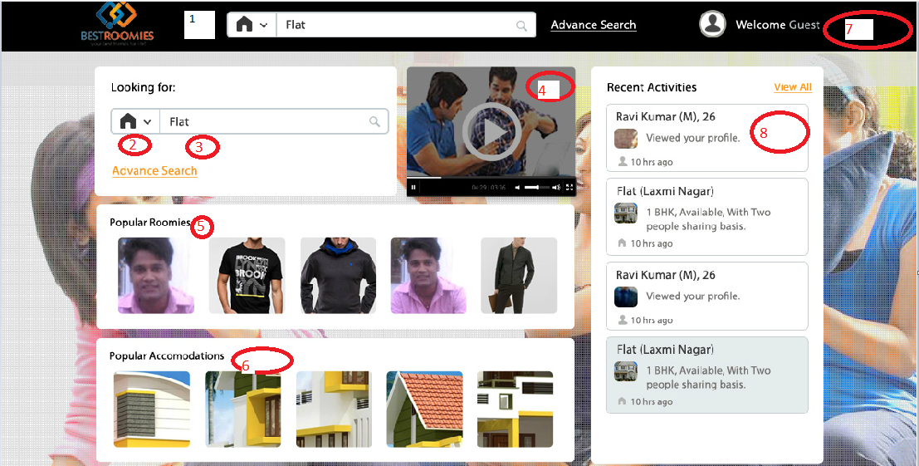

- The User should be able to look for House or Roommate to live with , based on Location
- &3 The Search would include Home/Roommate , Gender , and geographic location
4. There will be video to let the user know about the product and its real life application
5 & 6 . Reccomended Houses for Girls , Recommended houses for low budget , Recommended houses for high budget , Popular roommates
7. Sign In , Sign Up and Post your Property
8. Feed about latest postings , signed in user will get information about his profile

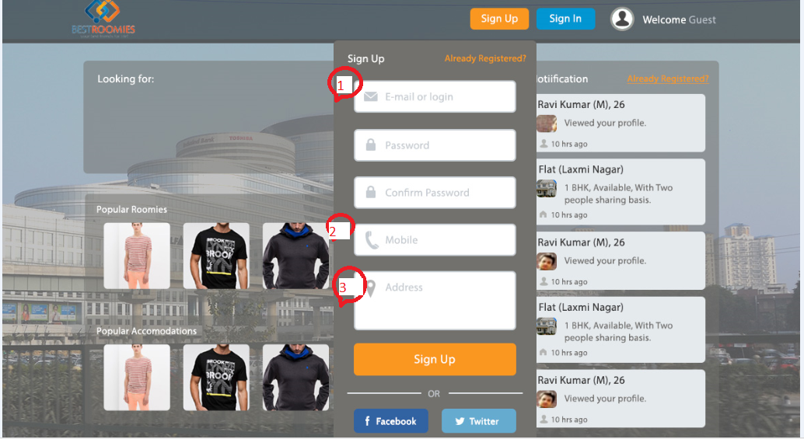

- Email verification would be needed to view listings
- Mobile Verification would be needed to contact users
- Address would be used to identify current location of user
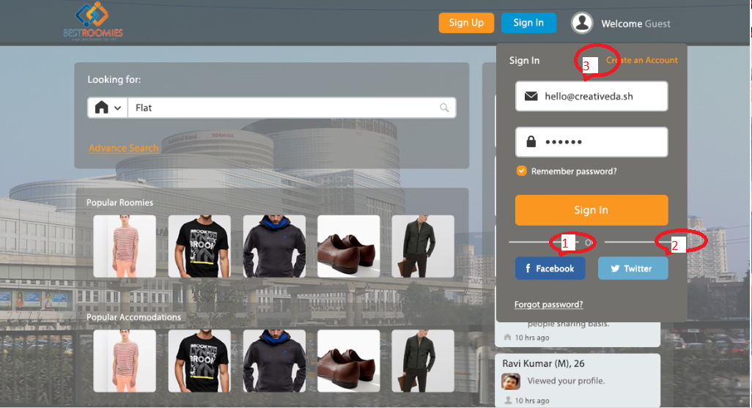

- Signup using Facebook account would only be allowed for users with more than 6 months or 1 year of activity
- Signup using Gmail / Googleplus would be another option

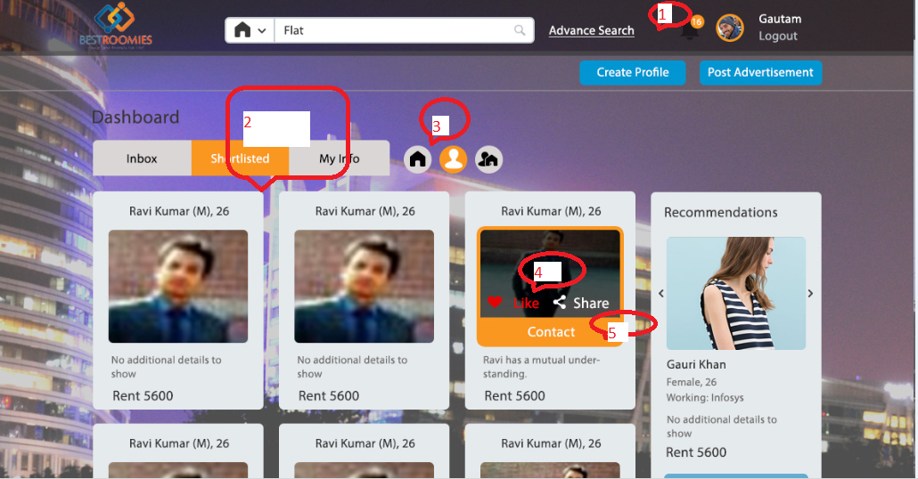

- Notifications alerting posts on Houses and Roommates
- And 3. Dashboard would enlist the profiles and houses favorite by user
- User would be able to contact other profiles /landlords using the WebMessaging feature
- Recommendations would be for premium listings

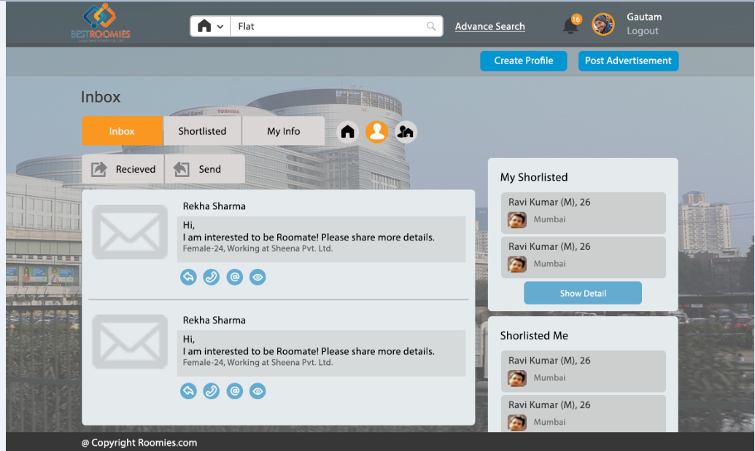

- Inbox feaure would be used to view the messages between users
- Users would be able to view others who have shortlisted them and they have shortlisted

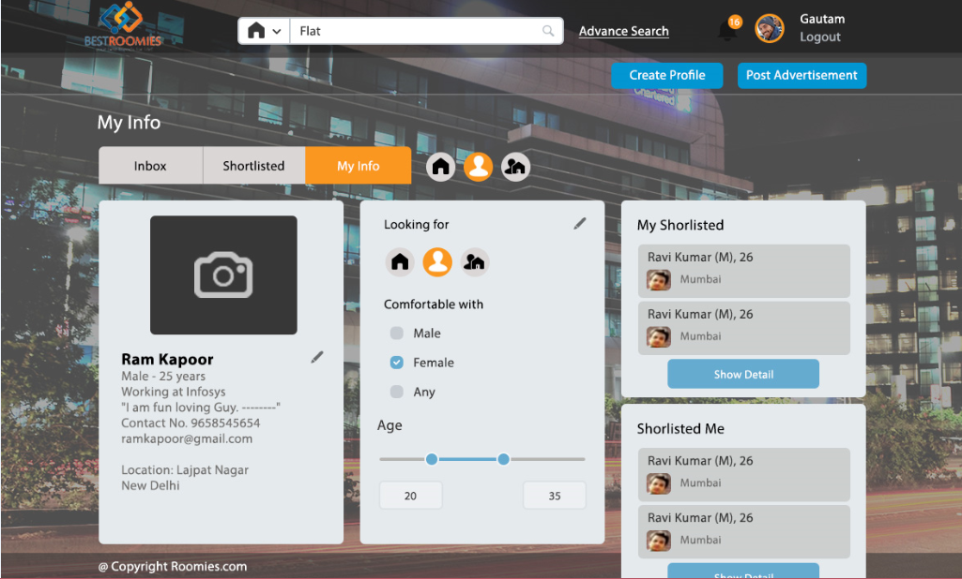

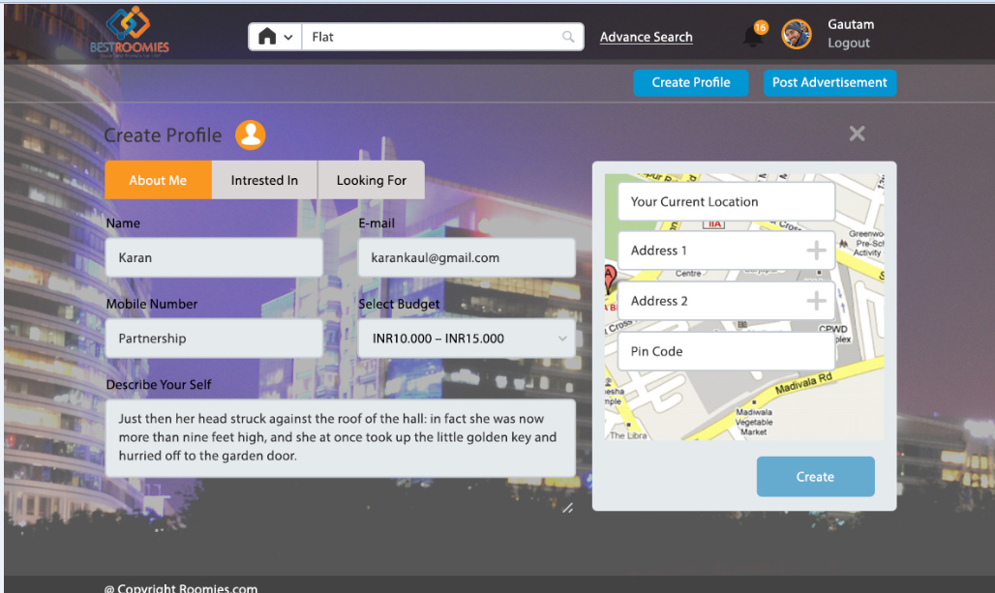

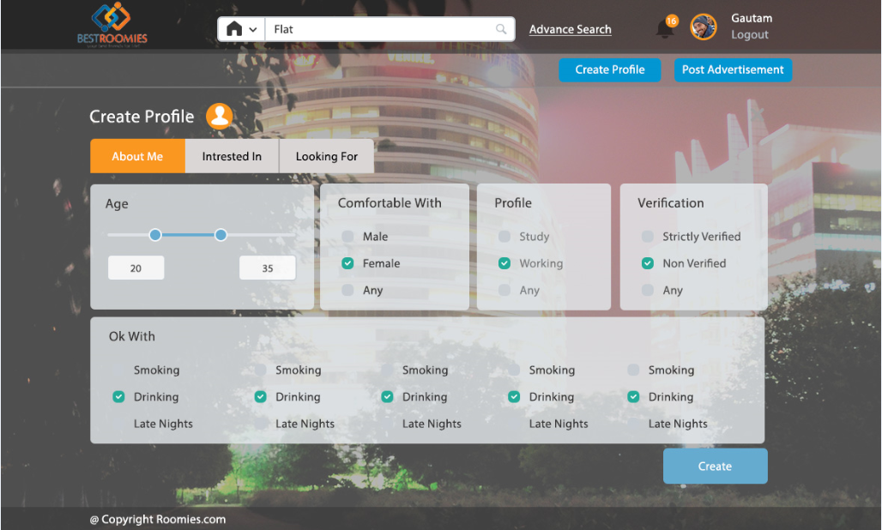
- There will be text where user describes himself / herself
- User shall enter her/his Professional /personal information
- Every user would need to upload photo
- Kind of people they are looking to meet

Posting of House
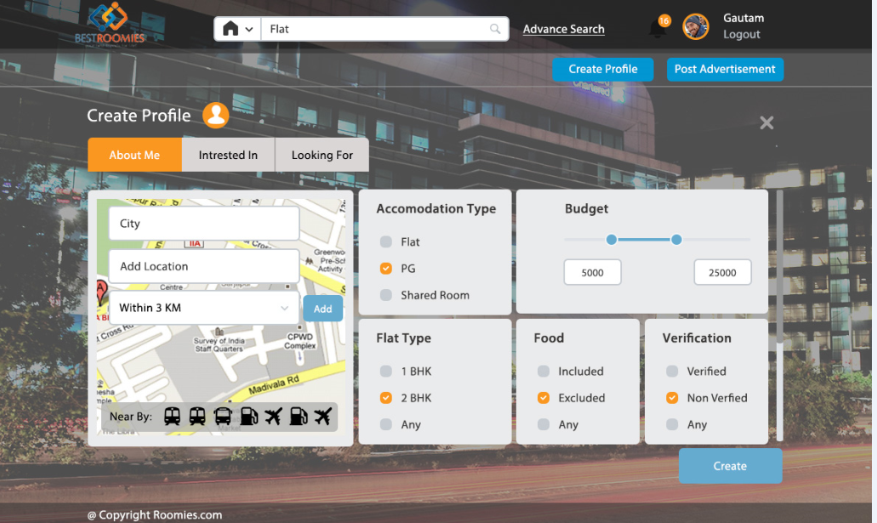

- The landlord should be able to easily enter all details about property
- Also the type of people he is looking for as tenant
- Posting of Photos is a must for posting advertisement to site

RoomMate Listing
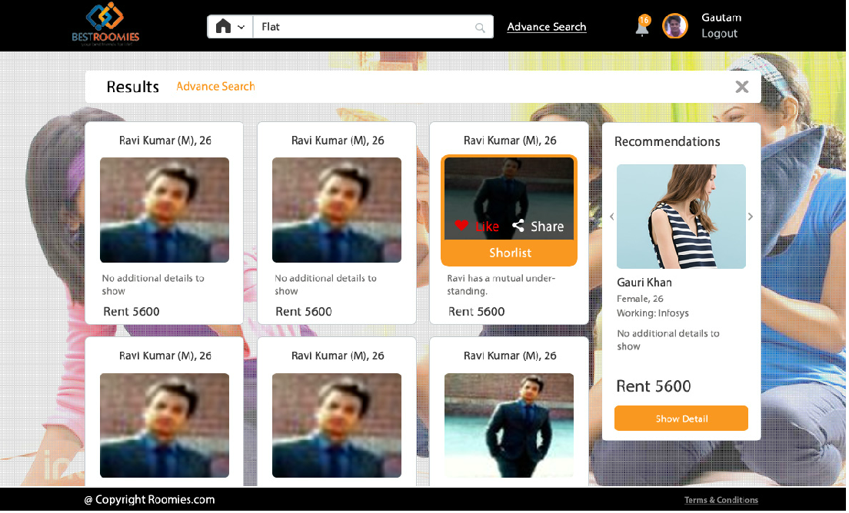

- Users should be able to do sort the listings based on established criteria
- Users should be add profiles to shortlist.
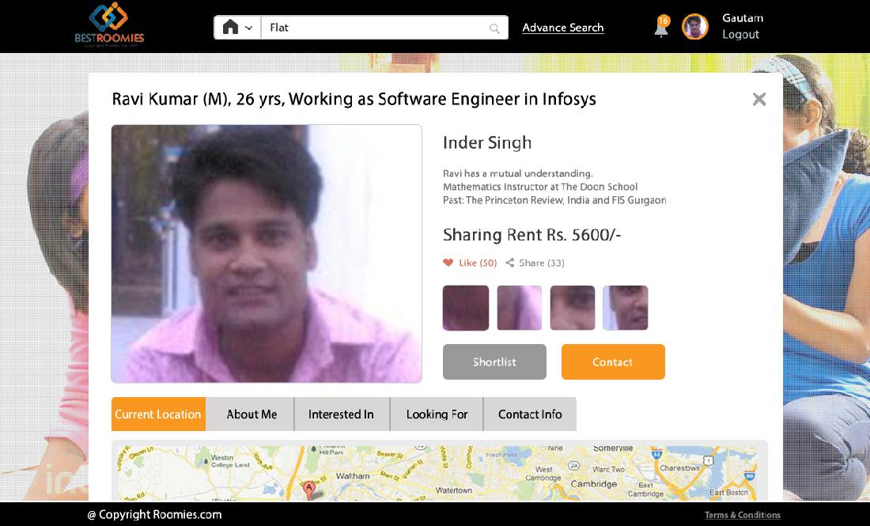

- RoomMate Listing shall have all the details of person arranged in tabs for easy to use sorting
- The Shortlist feature should be able add people to favorites
- The Contact feature should be able to contact the person shortlisted

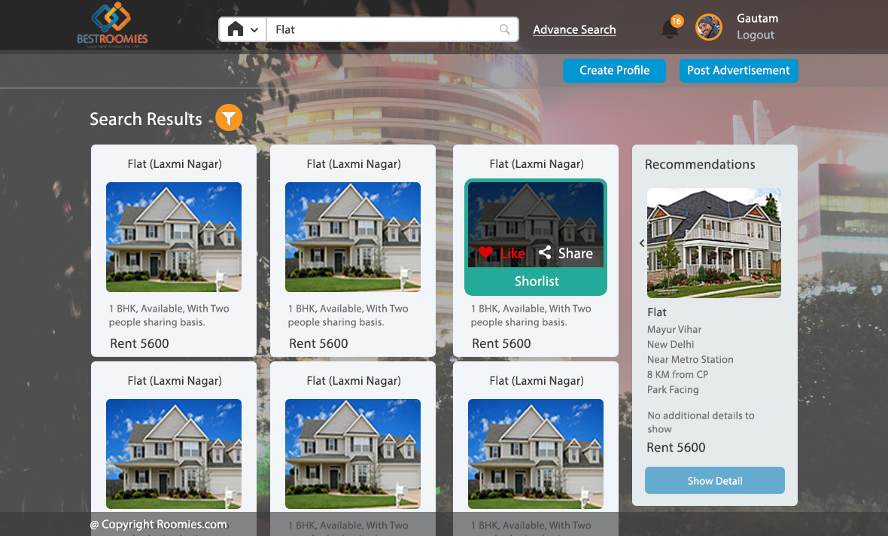

- The User should be able to sort Houses based on different filter criteria
- The user should be able to select/shortlist houses based on convieneince

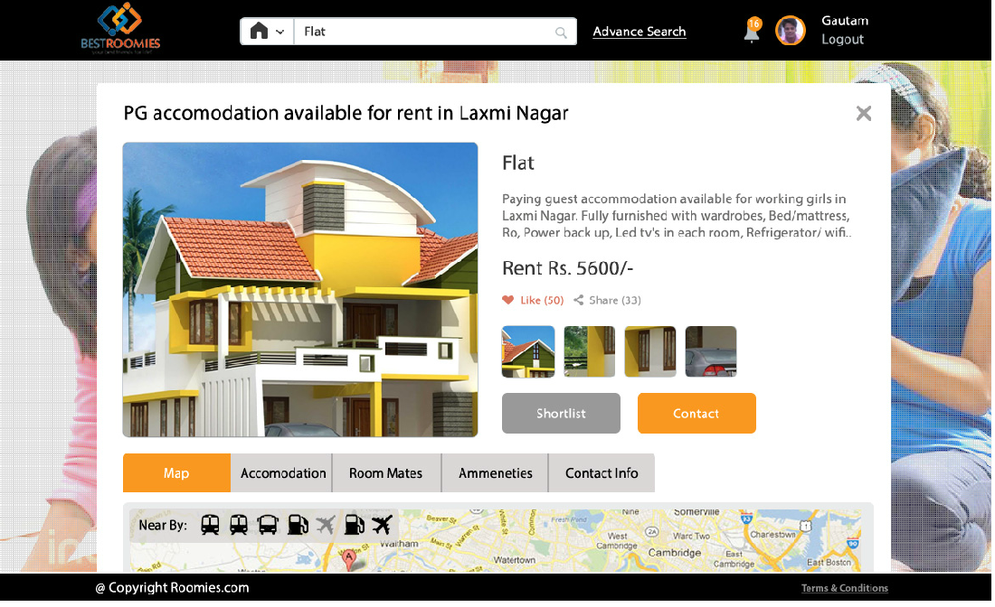
- Alll relevant details about house should be captured
- The user should be able to shortlist houses

XXX-1 | Functional Requirement (The system shall…)  Screen Shots/ Mock-Ups/ Flows  [Insert graphical presentation of the requirements (e.g., screen shots and/or mock-ups, process flows or models), if applicable. Otherwise you can remove this section heading]
XXX-2 | Repeat section above for each requirement.
XXX-2.1 | Sub requirement for Requirement 2.

REPEAT SECTION FOR ALL FEATURES (5.2, 5.3, 5.4, etc.)
Include a section for required output / reports.

External Interface Requirements

User Interfaces or Requirements (UI)
[Describe the logical characteristics of each user interface required – document only those requirements needed to clarify the screen shots / mock-up / flows included in the functional requirements; reference the functional requirement number. Examples include GUI standards or style guides, font, icon, image, color scheme standards, standard buttons for every screen /window (e.g., help link), message display conventions. Note that the format to reference UI IDs in other sections is: UI-req #-#, e.g., UI-OML-1-1 or UI-OML-2.1-1]

Number |  |  | Field Name | Object Type | Completion Required | Comments
UI | OML-1 | 1 | Description | Text | Yes | Sample: Default value is …
UI | OML-1 | 2 | Active | Check box | Yes
UI | OML-2.1 | 1 | Search | Button | Yes
UI | OML-2.1 | 2 | N/A | Font | N/A | Sample: Global font is Arial
UI | ADM-1 | 1 | Zip Code | Text | Yes | Sample: This field is editable
UI | ADM-2 | 1 | Date | Text | Yes | Sample: This field is hard-coded
UI
UI

Hardware Interfaces or Requirements (HR)
[For 3rd party vendor applications, describe characteristics of each interface between the hardware and software components of the system. List all supported devices.]

Number |  | Requirement
HR | 1
HR | 2

Software Interfaces or Requirements (SR)
[For 3rd party vendor applications, describe the relationships between this product and other software components (e.g., database, operating system, tools, etc.) by name and version.]

Number |  | Requirement
SR | 1 | SMS Verification API
SR | 2 | Video Conferencing API

Communications Interfaces (CI)
[State the requirements for any communication functions the product will use; for example, email, web browser, ftp, output written to a print server, electronic forms, data transfer rates, etc.]

Number |  | Requirement
CI | 1 | Email
CI | 2 | SMS

Plan & Comments

# | Item | Status | Comment | Responsible
 | Get The Paper Mockups | Y |  | Sachin / Yogi
 | Get The Front End Mockups | Y |  | Sachin / Yogi
 | Validate with 20 users and 5 landlords | N |  | GautamK
 | UX designer to Develop in CSS Bootstrap |  |  | GautamM
 | Validate with 20 Users |  |  | GautamK
 | PHP Developer to develop using Zend Framework |  |  | GautamM/Somesh
 | Test with Users |  |  | GautamK
 | Develop Database |  |  | GautamM
 | Test With users |  |  | GautamK
 | Go Live |  |  | Everyone ☺

1. Visitor Interaction

Req | Description | Comments
1.1
1.2
1.3
1.4

2. Editing, Updates and Administration

Req | Description | Comments
2.1
2.2
2.3
2.4

3. Sitemap and Navigation

Req | Description | Comments
3.1
3.2
3.3
3.4

4. Content Management

Req | Description | Comments
4.1
4.2
4.3

5. Tracking (website statistics)

Req | Description | Comments
5.1
5.2
5.3

6. Search Engine Optimisation (SEO)

Req | Description | Comments
6.1
6.2
6.3

7. Editor Interface (Web Content Management System)

Req | Description | Comments
7.1
7.2
7.3

8. Accessibility

Req | Description | Comments
8.1
8.2
8.3

9. Styling and Design

Req | Description | Comments
9.1
9.2
9.3

10. Security

Req | Description | Comments
10.1
10.2
10.3

11. Hosting

Req | Description | Comments
11.1
11.2
11.3

12. Maintenance and Support

Req | Description | Comments
12.1
12.2
12.3

13. Other Requirements

Req | Description | Comments
13.1
13.2
13.3

4. Appendices
- Roomys.in
- Flatmet.com
- Sulekha.com
- Grabhouse.com
- Flats.to
- Airbnb.com

